|  |  |  |
| --- | --- | --- |
| Response to:  Intel Corporation, Internet of Things Group (IOTG)  Project Title:  Computer Vision for Retail – Phase II    Submitted on:  30-Mar-2017 | | |
|  |  | Bosch_RGB_L_transparent |
| |  |  | | --- | --- | | Intel Corporation, Internet of Things Group (IOTG), USA | M/s Robert Bosch Engineering and Business Solutions Private Ltd. | | Name: Mr. Sanjay Addicam | Name: Mahesh Chikodi | | *Designation: Principal Engineer, IOTG* | Designation: Head of Sales, UK | |  | Telephone: +44-1895-83-8653 | | *Phoenix, Arizona* | Mobile : +44-779-296-4789 | | E-mail: [Addicam.V.Sanjay@intel.com](mailto:Addicam.V.Sanjay@intel.com) | E-mail : Mahesh.Chikodi2@uk.bosch.com | | *URL:* [*www.intel.com*](http://www.intel.com) | *URL:* www.bosch.com | | *Proposal Submission Date:* ***30-Mar-2017*** | |  |  |  | | --- | --- | | Validity | 3 months from date of submission | | Confidentiality – Copyright @ RBEI  This document and no part of it to be reproduced by any means or transmitted without the written permission of RBEI. This information is considered privileged and confidential, and its release would offer substantial benefit to competitors offering similar services. This document includes descriptions of methodologies and concepts derived through substantial research and development efforts. Therefore, it is the position of RBEI. that the use or release of the information contained in this document other than an evaluation of its contents as a basis for contract award is prohibited, and materials herein are not considered subject to release. | | | | |

Table of Contents

[1. Executive Summary 2](#_Toc478636804)

[1.1 The RBEI Bosch Benefit 2](#_Toc478636805)

[1.2 About Bosch 3](#_Toc478636806)

[1.3 Bosch in the Internet of Things 3](#_Toc478636807)

[1.4 The Bosch Commitment 4](#_Toc478636808)

[2. Project Overview 5](#_Toc478636809)

[2.1 Background 5](#_Toc478636810)

[2.2 Project Scope and Details 5](#_Toc478636811)

[2.3 Technical Scope 6](#_Toc478636812)

[2.3.1 Background subtraction and blob analysis 6](#_Toc478636813)

[2.3.2 Unsupervised People Counting Technique 7](#_Toc478636814)

[2.3.3 Deep Learning 8](#_Toc478636815)

[2.3.4 Direction and Height Estimation 8](#_Toc478636816)

[3. Implementation Approach & Methodology 9](#_Toc478636817)

[3.1 Agile Development Methodology 9](#_Toc478636818)

[3.2 Requirements Management (Stories) 9](#_Toc478636819)

[3.3 Project Steering and Control 10](#_Toc478636820)

[3.4 Change Management 10](#_Toc478636821)

[3.5 Quality Gates / Sprint Assessment 10](#_Toc478636822)

[3.6 Testing 10](#_Toc478636823)

[3.7 Sprint Reviews 10](#_Toc478636824)

[3.8 Continuous Code Integration 11](#_Toc478636825)

[3.9 Quality Assurance 11](#_Toc478636826)

[3.10 Proposed Sprint Plan and Activities 12](#_Toc478636827)

[3.11 Deliverables 13](#_Toc478636828)

[4. Additional Details 14](#_Toc478636829)

[4.1 Model Evaluation and Success Criteria: 14](#_Toc478636830)

[4.2 Out of Scope 14](#_Toc478636831)

[4.3 Assumptions and Dependencies 14](#_Toc478636832)

[4.4 Intellectual Property Rights 15](#_Toc478636833)

[5. Project Management, Reporting and Review Methodology 16](#_Toc478636834)

[5.1 Project Management 16](#_Toc478636835)

[5.2 Project Organization 16](#_Toc478636836)

[5.3 Reporting and Review Methodology 17](#_Toc478636837)

[5.4 Project Specific Risks and Mitigation 18](#_Toc478636838)

[6. Project Estimation and Commercial Summary 20](#_Toc478636839)

[6.1 Development Project Cost 20](#_Toc478636840)

[6.2 Payment Schedule 20](#_Toc478636841)

[7. Terms and Conditions 21](#_Toc478636842)

[8. Business Contacts 22](#_Toc478636843)

# Executive Summary

Robert Bosch Engineering and Business Solutions Private Ltd (RBEI) wishes to thank **Mr. Sanjay Addicam** of Intel Corporation, USA for providing an opportunity to submit this proposal for Phase-II of the development of Computer Vision project for Intel.

Internet of Things Group (IOTG) at Intel Corporation is undertaking an innovation project in order to connect information from cameras and RFID tags to better manage SKUs at retails stores. This will later be offered, upon successful pilot, to Intel’s retailers and brands.

The proposed end objective is to build a robust system for event based people counting and direction of movement, with height estimation. Bosch has already engaged with the Intel IoTG team on the Phase-I of the computer vision for retail project, and this current scope is for the extension of the project activity.

Bosch acknowledges the intent and purpose behind this solution framework and would like to support Intel with the full strength of both organizations from a research, technology and engineering perspectives. Given the objective that Intel has, we will come together to support with a roadmap that addresses Intel’s current objectives and future challenges with the required solution.

Bosch will bring together competencies and experience in working in multiple image processing and data analytics projects across industry verticals and we believe that our solution will meet Intel’s objectives.

Performance, Quality, Reliability and Value are key to a strong product strategy. This is the premise for this proposal document from Robert Bosch Engineering and Business Solutions (RBEI) Pvt. Ltd. (Bosch).

## The RBEI Bosch Benefit

RBEI is pleased to submit its proposal to the Computer Vision Phase-II requirement for Intel. We acknowledge the importance that Intel accords to its partners for its future and we recognize the value of innovation that is needed to sustain and grow an organization such as Intel. The team strongly believes in our ability to be one of the best partners in Intel’s journey towards value growth. We also envision Intel as one of our key strategic customers and are committed to delivering superior value through improved operational efficiency, innovative engineering solutions, competent workforce and flexible business models.

RBEI team will leverage its experience and learnings from working with Intel’s IoTG team on the former Retail Cloud Framework as well as the first phase of the computer vision project. We believe that our past association will form a strong foundation, which can help the teams work closely towards achieving the end objective of the pilot.

Additionally, the teams brings together competencies in the fields of image processing and analytics, which will help us deliver a seamless output tailored to Intel’s requirement.

## About Bosch

As a leading technology and services company, we take advantage of our global opportunities for strong and meaningful development. Our ambition is to enhance the quality of life with solutions that are both innovative and beneficial. We focus on our core competencies in emerging technologies as well as in products and services for professional and private use.

Interactive link to know more about Bosch: <http://www.bosch.com/worldsite_startpage/en/Bosch_Today.aspx>

Bosch Group took an early strategic step forward into the connected future. The leading international provider of technology and services acquired 'Innovations Software Technology' in 2008 and 'Inubit' in 2011, which furnished it with core technologies on business rules and business process management, a first in the context of the Internet of Things. Today, these software products are part of the Bosch IoT Suite, supplemented by device management and big data processing.

## Bosch in the Internet of Things

**World market leader in sensor technology**

More than one billion MEMS sensors were shipped in 2013. Bosch holds more than 1,000 patents and patent applications related to MEMS technology (micro-electromechanical systems).

**Connected products and new business models**

In Bosch’s vision of the future, each of its electronic products is web-enabled. It already offers numerous connected products as well as new services and apps. The focus of these activities stays true to the Bosch motto “Invented for Life” – innovations should be in people’s interest.

**Bosch already has extensive expertise in hardware and software**

Who will take the lead in the Internet of Things? IT companies or those who are experts in “things”? Bosch is well-established in both worlds: creating reliable products of superior quality that already contain a good amount of intelligent software.

**Lead user and supplier in Industry 4.0**

Bosch is currently realizing and testing use cases for Industry 4.0 in some 50 pilot projects. With over 260 production plants around the world, Bosch has extensive production know-how, stretching from the manufacturing of millions of automotive components to the customized manufacturing of packaging machinery.

**The Bosch Group is an energy market pioneer**

For many years, the Bosch Group has successfully developed and marketed pioneering solutions. These can be harnessed by the energy industry in multiple fields, including electro mobility, wind energy, thermo technology, storage technology, and building technology.

## The Bosch Commitment

Bosch believes in customer delight and is committed to the success of the Computer Vision program. The success of the program is dependent on the three key delight areas of Quality, Cost and Delivery.

A. Quality

* Readiness of the Technology
* Maturity and reliability of the engineering and manufacturing process
* Metrics based assessment

B. Cost

* Lean engineering effort and therefore development budget
* Optimal cost of materials
* Low running costs

C. Delivery

* On-time, on-target, on-spec deliveries
* Single window to entire program
* Ownership of ecosystem, deliverables and commitments

# Project Overview

This section outlines the details related to the project background, proposed scope and perceived technical approach towards attaining the end objective of people count, direction and height detection in a retail store environment.

## Background

The overall idea behind this project is to build a robust system for event-based people counting and direction of movement, along with height estimation.

For this purpose, the project aims to utilize the information provided by video cameras located on all the ceiling. From the images from these cameras, depth maps will be estimated followed by people counting, direction and height estimation.

## Project Scope and Details

The following are the broad modules which will be catered to, towards the realization of the end objective of the project:

1. Depth map estimation

2. People count around store entry/exit from camera images

3. Direction of movement (right to left, left to right, north to south, south to north)

4. Estimation of the heights of people around the camera

Project execution will be from RBEI’s offshore location at Bangalore, with the team requiring store level inputs from Intel team on a need basis for efficient project execution.

End-to-end project delivery responsibility will rest with RBEI, with identified representation from the customer end to enable a smooth handshake and progress of activities as detailed in this proposal.

Further, RBEI proposes to augment the engagement after the proposed project. RBEI shall coordinate a management review with the customer at the end of the project to discuss the roadmap for collaboration and furthering a strategic data analytics engagements with Intel.

* **Estimated Duration**: 5 months from Kickoff
* **Tentative start date**: 2nd May, 2017
* **Location**: Delivered from Robert Bosch Engineering and Business Solutions, Bangalore
* **Travel**: Currently no travel is planned for the associates involved in the project. (Required travel may be planned on a need basis and billed at actuals)

## Technical Scope

### Background subtraction and blob analysis

A simple approach, which is generic and real-time, is to do background subtraction followed by segmentation. We can then perform blob analysis and according to the size, we can cluster groups and can calculate the people count.

**Expected Setup:**



**Outlier removal**: We can add a few boundary checks in order to remove false positives. Since we are using top-view based people counting, we can assume that the heads detected will be approximately sphere-shaped objects.

For accurate foreground head segmentation, we can use 3D clustering, region growing, connected component labelling based on depth image. We need to look for a sphere-shaped contour in 2D view using edge detection.

A challenge would be to compute the depth image accurately from the stereo camera data. In order to remove artifacts, we need to apply morphological operations.

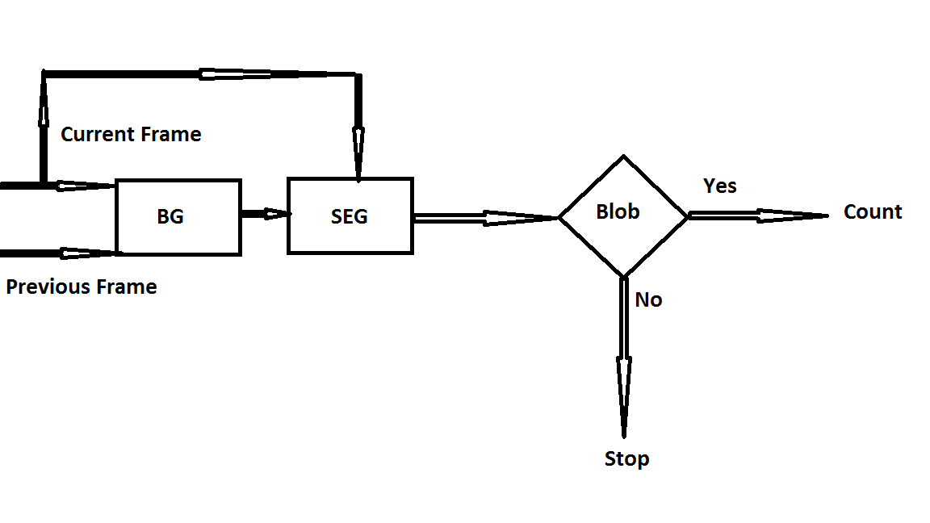

Although iteration 1 method is fairly robust, there remains the possibility that the performance is not as per expectation. This may be due to multiple causes such as dense crowd, occlusion, variation of illumination, color texture, etc. Therefore we will in parallel be exploring iteration 2 which is detailed below.

**Expected Disparity Map (for filtering shadows):**

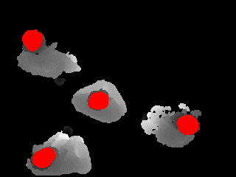

### Unsupervised People Counting Technique

An unsupervised method would be to use point tracker to track visual features and cluster the trajectories, under the independence assumption that the number of cluster centers is taken as number of persons. However, this basic assumption doesn’t always hold because of occlusion, variation of illumination and color texture.

As person’s head is near to the stereo camera, hence detecting the head is equal to finding the suitable local minimum region in depth image and using the nearest neighbor for tracking the trajectory.

Water Filling Method Explained: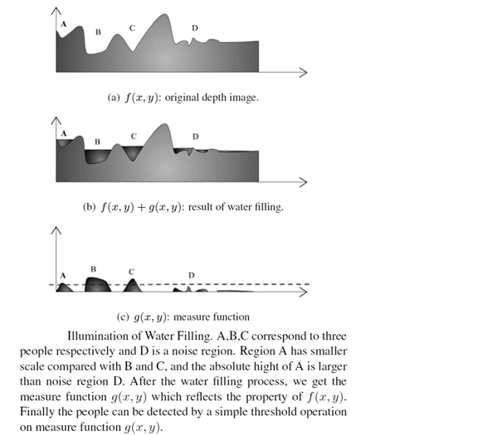

Nearest neighborhood multiple target tracking algorithm will be used to get trajectory for every person. In NN tracking algorithm it always updates the tracking filter with the measurement closest to the predicted state.



### Deep Learning

In case the real store data is complex and the purely image processing based approaches mentioned above do not provide adequate accuracy, then we will employ deep learning modules for counting people. Since only the head will be visible, we will estimate the count by detecting bounding boxes that contain heads in the image. We will train our model on INRIA Person dataset and also on lab data.

### Direction and Height Estimation

In the first method, we are detecting the heads of people present at a particular time interval in the store. Since we already know the height of camera from floor, we can estimate the person height using the formula:

Height = (H – D) where H: is height from camera to floor and D: is depth of head found from depth-map.

For estimating the directions, we will be using Optical Flow (Lucas-Kanade Method).

# Implementation Approach & Methodology

## 

## Agile Development Methodology

The development methodology used for this project will be an Agile Scrum method where the set of activities which are a part of the project scope will be executed and delivered as sprints.

At the end of each sprint, a review will happen to determine if the project is on the right path and whether any corrective actions need to be taken. The following block diagram defines the different phases in this methodology and the activities carried out in each phase.

**Principles of Agile Development at RBEI:**

## Requirements Management (Stories)

To define the Customer requirements, user stories have to be created. User stories are more detailed in the form of product backlog items.

Stories make up the product backlog, the release backlog and the sprint backlog. Stories/backlog items are prioritized by the Product Owner to create the product, release, and sprint backlogs for each sprint. From product to release and sprint backlog these backlog items have to be further detailed.

Stories should be written on index cards and should include a role, action and a business value. It is recommended that the following format be used: As a <role>, I want to <action>, in order to <value>. Stories should be categorized by type (feature, technical, non-functional, etc.,) and should be grouped with like/similar stories. Stories can be categorized as blocked if there are questions or technical problems with the story. The Product Owner (and Scrum Master) has to clarify and resolve the open questions or technical issue within one day.

Stories have to be estimated by the Scrum Team to determine complexity and time needed to complete the task. The Product Owner shall be available for further inquiries and provide additional information about a story’s requirements, if there is a conflict on the point estimation. Stories that require more than two person days to complete should be broken into smaller tasks. It is recommended that the estimation process use the planning game and the following point values for estimation: 0, 1, 2, 3, 5, 8, 13, 20, 40 and 100. The full Scrum team commit themselves to the point estimation assigned to each story. The Product Owner may need Scrum Master Supports the methodology with run of the expenditure estimation by methodic tools named at the top ("Planning Game" and point estimation).

## Project Steering and Control

Planning (initial plan, current forecast) and actual values have to be compared. The project status must be reported at regular intervals – at least at every phase transition (project phase or sprint) to the required functions specified by the project organization. The reporting includes schedule progress, cost, scope & quality and risk. Major instruments for development, used by the Scrum Team, are burn down charts and velocity charts.

## Change Management

A change is an alteration to the approved project plan (schedule and/or costs) or a project scope. Target is the systematic handling of change requests. All scope changes are tracked through the product, release or sprint backlogs. Stories can only be added by the Scrum Team to an ongoing sprint.

## Quality Gates / Sprint Assessment

Quality Gates (QG) and Sprint Assessments (SA) have to be conducted within the project plan at the end of each phase. Those quality assessments are designed to be a check point in the project to make sure both RBEI and Intel agree on the current status of product development and that the required tasks are being completed.

Mandatory roles for each QG/SA include: the Project Manager from Intel, the Product Owner from Intel, the Project Manager from RBEI and the Scrum Team.

## Testing

Scrum teams will perform unit testing during each sprint. Integration testing to be performed when all modules are developed and integrated. Product Owner is responsible for validating the functionalities delivered in each sprint. User acceptance testing and live testing to be conducted at the end of integration testing, as indicated in the project plan.

## Sprint Reviews

Sprint reviews will take place regularly. It is recommended that a review should take place at the end of each sprint. The minimum number needs to be determined at the beginning of the project.

The review is moderated by the Scrum Master and should last a maximum of four hours. The full Scrum Team, the Product Owner and all stakeholders should attend the meeting. A demonstration of the running system shall be conducted during the meeting which is recommended to be taken by the Product Owner. Acceptance of the demonstration and test results take place during this meeting.

Information about strengths, weaknesses, expected problems in future sprints, etc. should be discussed and documented during the sprint review meeting. If a so-called retrospective is planned, it should be conducted during this meeting.

## Continuous Code Integration

Continuous integration of code should (if possible) occur frequently. It should also include:

* Code check-in with necessary documentations
* Unit tests
* A full and clean compilation of the application

It is recommended that continuous refactoring of the code be done to optimize the code. The code should be improved before it is checked-in and should adhere to a coding standard. It should include syntax convention, common design patterns, code documentation standards etc. Coding check-style as a tool is recommended to verify that coding standards have been met.

Frequent code reviews are required which needs to be conducted by other members of the RBEI development team as well as technical lead from Intel.

## Quality Assurance

Embedded in the overall concept of quality assurance, we orient ourselves towards the following Quality Assurance Framework to ensure qualitatively high-grade services at the project level:

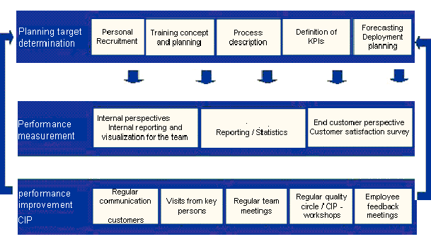

The quality framework consists of three levels:

**Level-1: Planning:**

Planning of the service to be rendered is at the highest level. It involves careful planning of necessary human resources and recruitment of suitable employees, conception of trainings to be carried out, their organizational planning as well as detailed description of the processes covered. In addition, the Key Performance Indicators (KPIs) are defined, which also includes the determination of corresponding reporting for measuring the KPIs as well as forecasting the volumes to be expected and the corresponding personnel deployment planning. The planning is done keeping the project implementation in focus and is adjusted on the basis of the results achieved in the current project.

**Level-2: Performance Measurement:**

The second level describes the performance measurement of the service actually rendered. The quality of service is rendered transparent for both internal jobs as well as for customers through extensive assessments. The rendering of services is looked at from three different perspectives:

* The internal perspective of the RBEI vis-à-vis aspects such as employee, productivity, efficiency etc.
* The perspective of the customers as per the agreed reporting specifications for measurement of the KPIs.
* The perspective of the end customers, who are taken into consideration through e.g. customer satisfaction surveys.

With these measures, a direct feedback is given as to whether the set targets could be achieved or whether individual parameters still have to be adjusted in the planning.

**Level-3: Performance Improvement - Continuous Improvement Process (CIP)**

The third level involves a detailed analysis of the service rendered and the initiation for improvements, which is the CIP. This analysis is carried out in various combinations, starting with regular communication of the responsible contact personnel as well as mutual visits of key personnel during the performance discussions in internal team meetings to the quality circles with all the project participants. Employee feedback discussions for performance improvement of individual employees are also taken into consideration here.

By orienting project plans towards the Quality Assurance Framework it is ensured that this concept is taken into consideration in the project implementation. We plan tasks which are derived concretely from the areas described above (e.g. personnel planning, recruiting, reporting, etc.).Thus, we ensure right from the beginning that the project is promising and can be successfully executed.

## 

## Proposed Sprint Plan and Activities

RBEI proposes 3 sprints of duration 4-8 weeks to complete all the tasks in scope. The duration of each sprint is not same considering the duration of individual tasks that are part of that sprint. Deliverables of each sprint are mentioned in section 3.11.

Project Managers, Product Owner and Scrum team will conduct Sprint Planning meetings before commencing each sprint to clarify on the requirements and finalizing the task details. Once a sprint is over, all stakeholders will participate in Sprint Review meeting. The purpose of the Sprint Review meeting is to demonstrate the Sprint deliverables and receive acceptance.

Product Owner from Intel needs to accept and approve the deliverables of each sprint within one week of the Sprint Review meeting. In case of any review feedback during Sprint Review meeting, Scrum Team will estimate the effort and add it to Product Backlog. This will then be taken up as new story in a later Sprint. Below is the sample Sprint plan and associated activities:



## Deliverables

RBEI Proposes the below mentioned intermediate deliverables in each sprint. We will define billing milestones accordingly.

Product Manager from Intel needs to review these deliverables and provide acceptance within one week of Sprint Review meeting.

|  |  |  |  |  |  |
| --- | --- | --- | --- | --- | --- |
|  |  |  |  |  |  |
|  | **Sprint** | **Duration** | **Timeline** | **Deliverables** |  |
|  | **Sprint 1** | **10 Weeks** | **May 2017 - Mid-July 2017** | **1. Finalized Background Subtraction Algorithm & Blob Analysis 2. Finalized algorithm for Water filing & Local Minima** |  |
|  | **Sprint 2** | **6 Weeks** | **Mid-July 2017 - August 2017** | **1. Finalized Algorithm for deep learning approaches 2. Algorithm for height estimation.** |  |
|  | **Sprint 3** | **4 Weeks** | **September 2017** | **1. Refinement to algorithms 2. Bug Fixes** |  |
|  |  |  |  |  |  |

# Additional Details

## Model Evaluation and Success Criteria:

People detection in each frame with 80% accuracy is achievable. For people count, we also need tracking (since we should not count the same person who may be moving slowly).

Direction ground-truth can be established by splitting each frame into four quadrants, but this still needs to be defined more clearly. Accuracy numbers related to height estimation also requires further deliberation.

Upon the completion of Sprint 1, the team will revisit this section and freeze on the accuracy numbers.

## Out of Scope

* Face detection and demographic classification is considered out of scope for this phase of the project
* The solution deliverable will be findings in the form of python code. Integration and deployment of the model with any existing systems is out of scope for current project
* Any changes to original scope or enhancement shall call for re-evaluation of the efforts, time and cost and needs to the change management process
* RBEI assumes that, integration with any other ongoing Intel project is out of scope. In case, any such integration point is required at a later stage, scrum team needs to estimate the effort separately and to follow the change management process
* Creation of reports using any reporting tool is not considered as part of this solution. This being a pilot project, final outputs will be viewed in console by executing Python code or by exporting the end results in a CSV file
* Any coordination required with the retail store in relation to the placement of camera/antennae/ items is to be coordinated by Intel team and considered to be out of scope for RBEI

## Assumptions and Dependencies

* Algorithms will be developed based on the video captures from the Computer Vision lab set up at RBEI premises; there may be a need to validate and fine tune the same for a production environment
* We will be using 80% of the frame size of the image as the RoI (Region of interest), in order to trigger the count of people
* Any lab related procurements this phase of the project will be billed at actuals to customer
* Objects having a height of less than 4 feet will not be considered for detection
* Baby prams/mannequins, etc. will not be considered for detection

## Intellectual Property Rights

As a part of the project activities, there is the possibility of a design of experiment approach for the execution of certain modules of the project leading to collaborative innovation.

In case such a patentable solution is developed as part of the project implementation, the patent over the solution will be held jointly by both parties subject to prior discussion and mutual agreement.

# Project Management, Reporting and Review Methodology

## Project Management

RBEI will appoint a project manager, he / she will coordinate with Intel for the complete project execution. RBEI – Project Manager is the single point of contact for the project.

## Project Organization

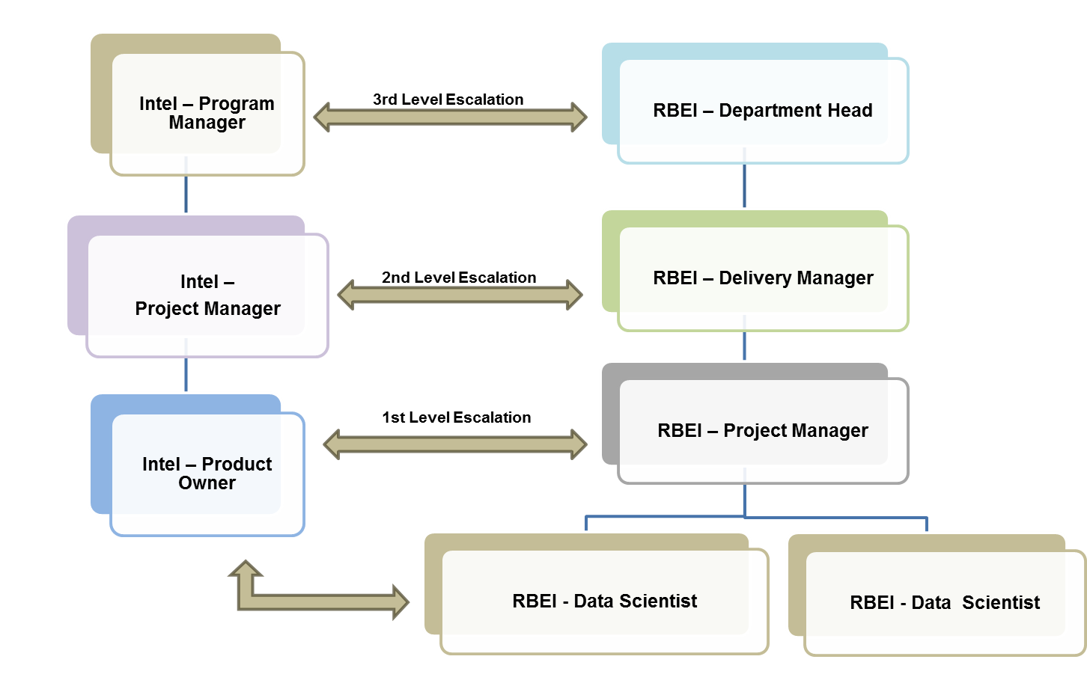

Key roles and responsibilities of RBEI positions mentioned below:

|  |  |
| --- | --- |
| **RBEI** | |
| **Role** | **Responsibility** |
| **Project Manager (Scrum Master)** | * Administrative control of RBEI project team * Project inputs to Intel Program Manager * Provide resources for the project * To resolve issues escalated * Responsible for overall project management * Invoicing/billing * Support in activity planning * Sprint planning & execution * Task allocation and schedule monitoring * Co-ordination with project support and Intel functional architect and Design team * Project planning, tracking and delivery * Clarification for invoicing / billing |
| **Data Scientists (Scrum Team)** | * Work with the Product Owner to analyze and decompose the Product Backlog items * Help create and maintain the Sprint Backlog, Sprint * Demonstrate the product at the end of each Sprint during the Sprint Review * Develop algorithms * Execute designated tasks in each sprint * Implement action items that come out of Retrospectives |

|  |  |
| --- | --- |
| **Intel** | |
| **Role** | **Responsibility** |
| **Program Manager** | * Responsible for project delivery * Overall project responsibility * Participate in joint reviews with RBEI * Approves change requests |
| **Product Owner** | * Providing requirements/clarifications * Prioritization * Deployment schedule * Acceptance testing and deliverables approval |

## Reporting and Review Methodology

|  |  |  |  |  |
| --- | --- | --- | --- | --- |
| **Event** | **Audience** | **Method** | **Frequency** | **Topics** |
| **Weekly Status Reports** | All Stakeholders | Document/ Presentation | Weekly | Summary, Schedule Changes, Bug-Updates |
| **Sprint Planning** | Intel Project Team & RBEI Project Team | Audio / Video Conference / Skype Conference | Beginning of Sprint | Task Prioritization and sprint plan |
| **Sprint Review** | Intel Project Team & RBEI Project Team | Audio / Video Conference / Skype Conference | End of Sprint | Demonstration of Completed Stories & Acceptance |
| **Management Review Meeting** | Management Team | Audio / Video Conference / Skype Conference | Monthly / As needed | Overall Project Status, Risk, Issues etc. |

## Project Specific Risks and Mitigation

|  |  |  |  |  |
| --- | --- | --- | --- | --- |
| SL No | Risk Description | Mitigation Plan | Contingency Plan | Responsibility |
| 1 | Delay in sign-off of formal agreements (SOW & MSA) and PO – Start of the project will be delayed which has impact on epic execution schedule. | Use Escalation mechanism defined.  RBEI keeps updated daily basis. | Kick off will be planned only after sign-off. Initiate the process as resource ramp up lead time would be minimum of 6 weeks. | RBEI and Intel |
| 2 | Change in scope after baseline | Changes to be evaluated and if necessary, schedule and additional pricing to be discussed and agreed | Prototype driven development. Requirement to be frozen at concept level. | RBEI and Intel |
| 3 | Delay in getting receivables and required clarifications sought by RBEI | Impact on the project schedule to be addressed with Intel to arrive at a workable solution | Intel coordinator proxy to be identified | Intel |
| 4 | Non availability of customer project coordinator (SPoC) | Intel to ensure the availability of SPoC before start of the project | Commitment from Intel Management on SPoC availability | Intel |
| 5 | Unaware of Statutory requirements, legal implications, laws of land | Discuss and address legal implications and statutory obligations with client SPoC |  | Intel |
| 6 | Complex and new concepts may require several validations which may require additional effort or deviation | Prototype approach to clarify concepts. If deviation beyond certain agreeable level effort to be re-estimated and agreed. |  | RBEI and Intel |
| 7 | Height estimations may not be within acceptable accuracy limits due to limitations of hardware | Look at methods such as camera calibration in order to improve accuracy numbers |  | RBEI |
| 8 | Accuracy numbers may vary when the algorithms developed in our lab environment are tested for a production scenario | Intel to provide production level store data to RBEI project team before start of the validation stage |  | Intel and RBEI |
| 9 | Getting **stereo video** from both the cameras simultaneously is a challenge. This works fine when camera is connected with a small USB cable.  The recording of both videos simultaneously is giving problems with longer cables. | Testing with improved USB cable quality | Placement of PC close to the camera | RBEI |

# Project Estimation and Commercial Summary

Development Project Cost

|  |  |
| --- | --- |
| **Deliverables** | **Cost (USD)** |
| Computer Vision Phase-II overall project delivery | 72000 |
| **Total Costs** | **72000** |

Payment Schedule

| # | Milestone | Payment Percentage on Total Cost |
| --- | --- | --- |
| 2 | Sprint 1 Completion | 40% |
| 3 | Sprint 2 Completion | 30% |
| 4 | Project Completion | 30% |

# Terms and Conditions

**General:**

* Project kickoff: RBEI will need 1 week lead time to start the project
* Project Termination: In case of project termination, Intel shall intimate the RBEI team at least 1 month in advance. If the engagement is terminated prematurely, Intel shall be liable to pay service cost incurred for a period of 1 month
* This document is a proposal submitted by RBEI to Intel and is valid up to May 31st, 2017
* Price does not include any hardware or software procurement cost
* Details regarding timeline, start date, etc. will be finalized at the time of kick-off and the team will be formed as per the project plan

**Commercial:**

* Intel will issue a PO before the start of the project
* In addition an SOW document needs to be signed between both parties
* RBEI will raise invoice at the end of each milestone completion as per billing schedule indicated in the document
* Any taxes applicable will be billed at actuals
* Intel will make payments within 30 days from the date of invoice

# Business Contacts

|  |  |
| --- | --- |
| ***Sales Representative:*** | |
| *Name:* | Mahesh Chikodi |
| *Telephone:* | +44-1895-83-8653 |
| *Mobile:* | +44-779-296-4789 |
| *E-Mail:* | [Mahesh.Chikodi2@uk.bosch.com](mailto:Mahesh.Chikodi2@uk.bosch.com) |

|  |  |
| --- | --- |
| ***Project Management Contact:*** | |
| *Name :* | Aritra Basu |
| *Telephone:* | +91(80)6657-1588 |
| *Mobile:* | +91 (95)35364646 |
| *E-Mail:* | [Aritra.Basu@in.bosch.com](mailto:aritra.basu@in.bosch.com) |